Amazon clone web site

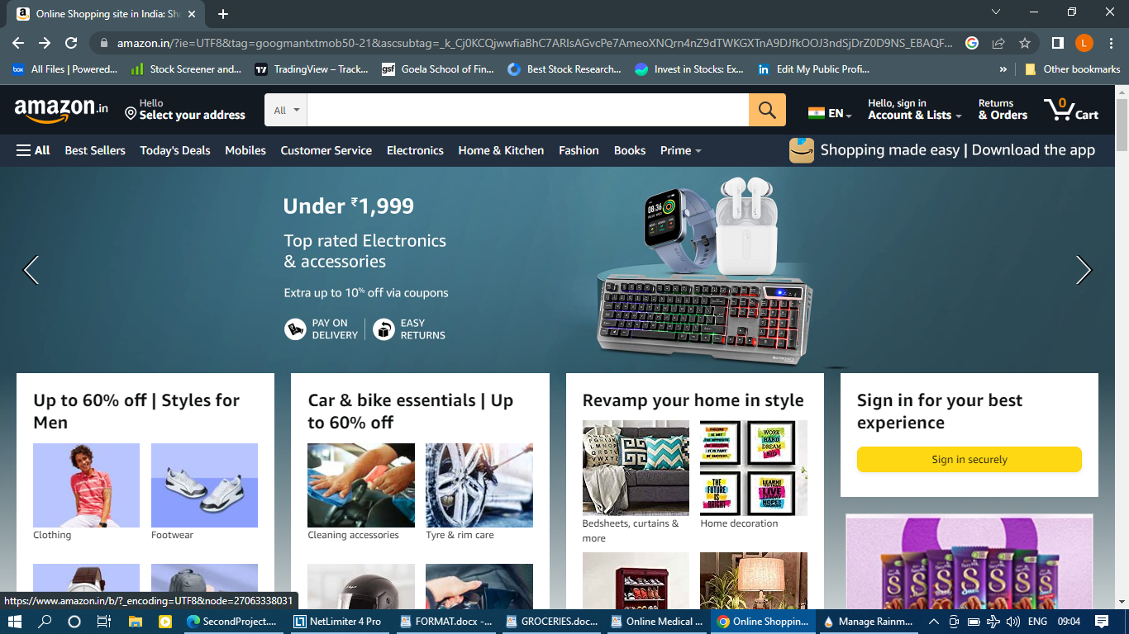

Project Name: Amazon Clone

Overview:

Amazon E-commerce refers to the buying and selling of goods or services using the internet, and the transfer of money and data to execute these transactions. You buying your furniture for your house, or you buying your favorite pair of shoes from an online store constitutes your participation in e-commerce.

Pages:

1.Homepage:

* Header section
* Amazon Logo, Location, Search Bar, Sign in, Order and Return & Cart
* Menu bar left side (collapsible) with different categories of products
* Image slider
* 3 section of different products categories
* 2 section of Products categories by horizontal slider

2.Filter page:

* Left Vertical window for filter section
* Filter is divided base on the products
* Right side different products description

3.Detail page:

* Images of product and description
* Products details
* Add to cart option
* Buy Now option

4.Payment gate

* Pay with Debit/Credit/ATM Cards
* Net banking
* Other UPI apps
* Cash on Delivery

Technologies Used in Project

**Front –End**

1.HTML

2.CSS

3.Bootstrap

4.React

**Dynamic:**

1.Javascript

**Database:**  
1.Mongodb

2.Json Data

**Code Compliers:**

1.Visual Studio Code

2.Git Bash

3.Google Chrome

4.Node Js

**Reference web sites**

<https://www.amazon.in>